**ITP Mini Project**

**Courier Management System**

For a seamless eCommerce shopping experience, it is essential to deliver the product promptly to the customer. And that’s where a professional courier service plays a vital role. 'FastTrack' courier company stores the relevant data of its clients and parcels in the form of dictionary. Create a dictionary for storing shipment information in key-value pairs. Shipment id is used as a key and list of other attributes like sender, receiver, start date, Delivery Date, Sender_location, Receiver_location, Delivery status, Shipping cost is associated with shipment id. Use the data shown in the table below.

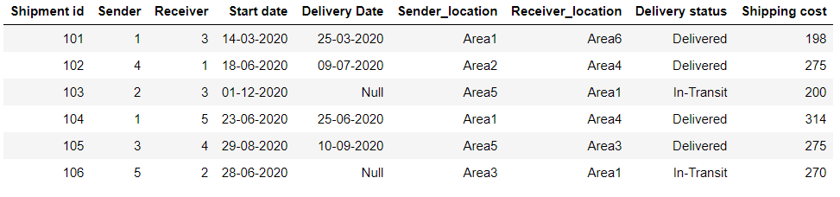

Use below table to refer to client’s data. Please note that a client can be a sender or receiver.

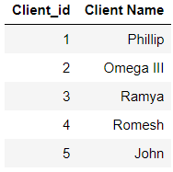

**Q1. Create a Dictionary of lists to store the information of shipments given in the table**

**Q2. Create a Dictionary of to store the information of clients given in the table.**

### Q3. Write a code to replace client’s id with their respective name in shipment dictionary using a loop and dictionary comprehension

### Q4. Print all shipment details that are sent by Phillip

### Q5. Print all shipment details that are received by Ramya

### Q6. Print all shipments which are in 'In-Transit' status

### Q7. Print all shipments which are delivered within 7 days of courier Start date

### Q8. Print all shipments which are delivered after 15 days of courier start date or not yet been delivered.

### Q 9. Write a function find_all_routes to display all possible routes from senders location to receivers location given in the dictionary for each shipment.[¶](http://localhost:8888/notebooks/Desktop/NPV_Content/ITP_mini%20Project/ITP_Mini%20Project.ipynb#Write-a-function-find_all_routes-to-display-all-possible-routes-from-senders-location-to-receivers-location-given-in-the-dictionary-for-each-shipment.)

### Graph data structure is used to represent network of pickup and delivery nodes. Consider a below graph diagram for given nodes in the table where sender location and receiver location is represented by node with number.

### Connection between two nodes shows route exists between those areas. E.g there exists a path from area 1 to area 2 but there is no direct route between area1 and area5. please note that this routes are bidirectional.

### To reach to area5 from area1 , delivery person can take any route like 1-2-4-5 or 1-2-3-4-5

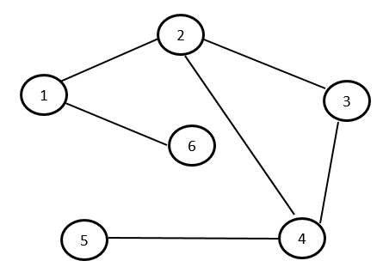

Any graph like the one shown above can be represented by matrix shown below. presence of 1 represents the route between nodes and 0 represents there is no direct route exist between the nodes. Create matrix for the network shown above and using this matrix find all possible routes from A to B.

